Cosmetic Ingredients
No. | Product Name | Product Specifications | Product Photos
1 | Niacinamide (Vitamin B3) | Niacinamide is a water-soluble form of Vitamin B3.  INCI: NIACINAMIDE  Appearance: White powder  Odour: Characteristic Odor  Storage Condition: Sealed, protected from light, and stored under conditions below 25 ℃  Shelf Life: 36 month  Application: Skincare products | 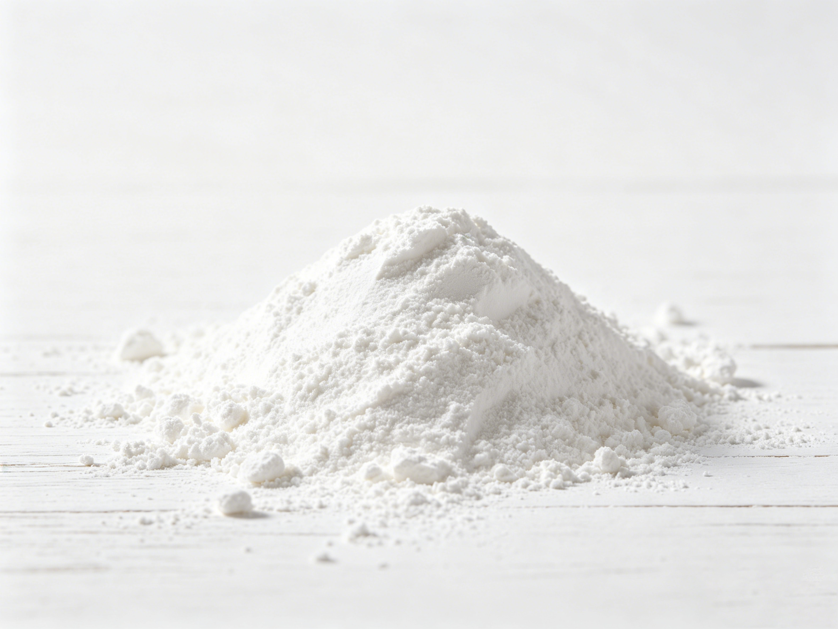
2 | Panthenol | Panthenol is a precursor of Vitamin B5.  INCI: PANTHENOL  Appearance: Colorless to slightly yellow viscous liquid  Odour: Characteristic Odor  Storage Condition: Store in a cool, dry, airtight, and light-protected place.  Shelf Life: 24 month  Application: Skin-care and hair-care products | 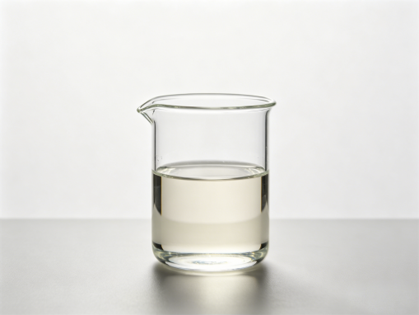
3 | Tranexamic Acid | Tranexamic Acid is an active ingredient widely used for skin brightening and improving hyperpigmentation.  INCI: TRANEXAMIC ACID  Appearance: White crystal powder  Odour: Characteristic Odor  Storage Condition: Store in a dry, airtight environment away from direct sunlight.  Shelf Life: 36 months | 
4 | Proxylane | Proxylane is a multifunctional active ingredient with anti-aging properties.  INCI: HYDROXYPROPYL TETRAHYDROPYRANTRIOL  Appearance: White powder or crystal  Odour: Characteristic Odor  Storage Condition: Sealed, stored in a cool and ventilated place away from light.  Shelf Life: 12 months | 
5 | Ectoin | Ectoin is a powerful amino acid–derived active.  INCI: ECTOIN  Appearance: White crystalline powder  Odor: Odorless  Storage Condition: Sealed, stored in a cool and ventilated place away from light  Shelf Life: 24 months | 
6 | Rosa Damascena Flower Water | Damask rose water, rich in actives.  INCI: Rose Damasccena Flower water  Appearance: Colorless Transparent Clear Liquid  Odor: Characteristic Odor  Storage Condition: Store in tightly sealed full containers in a cool,dark dry place.optimum storage temperature is 4℃ to 35℃(39.2°F to 95°F).Avoid uncoated metal container.  Shelf Life: 24 months  Applications: Sheet mask, Toner mask, facial mist, cream, lotion | 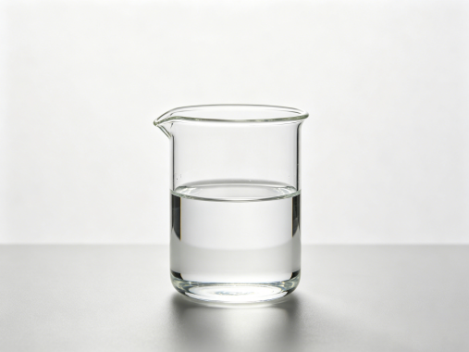

Food Ingredients
No. | Product Name | Product Specifications | Product Photos
1 | Compound Juice Stabilizer | A product used to stabilize fruit juice systems and improve dispersion within the beverage.  Function: Helps resolve issues such as phase separation and sedimentation during storage.  Application: Suitable for juices such as passion fruit, orange, lemon, lychee, apple, and grape. | 
2 | Compound Thickening Stabilizer | A product designed to stabilize dairy and related beverage systems.  Function: Helps address issues such as separation, oil-water splitting, and soy protein precipitation.  Application: Suitable for coconut beverages, yogurt, and cereal-based drinks. | 
3 | Coconut Water Powder Beverage | A powdered product used in coconut water beverages.  Function: Helps improve, adjust, and enhance the flavor of coconut water.  Application: Used in coconut water products. | 
4 | Flavors | A product used to add flavor to beverages.  Function: Enhances taste, provides a more natural flavor profile, and improves aftertaste.  Application: Suitable for all types of beverages. | 
5 | Cochineal | Compound food additives  Appearance: Red powder  Application: It can be used in foods that require coloring in red tones. | 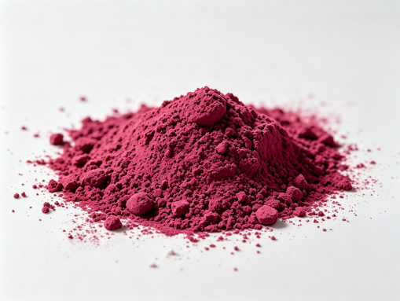
6 | β-carotene powder | Compound colorant  Appearance: Yellow to orange-yellow powder | 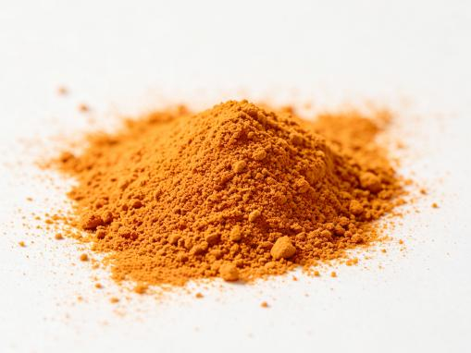
7 | β-carotene emulsion | Compound colorant  Application: It is widely used in the food industry | 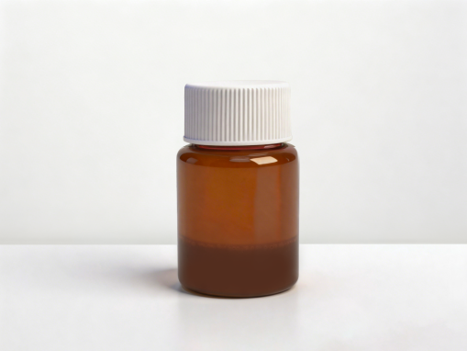
8 | Purple Pigment | Compound food additives  Application: Frozen desserts (excluding edible ice)、jam, baked goods, and fruit and vegetable juice (pulp) beverages、candies and instant rice and flour products、compound seasonings. | 